***AWS:***

***1. Login Screen***

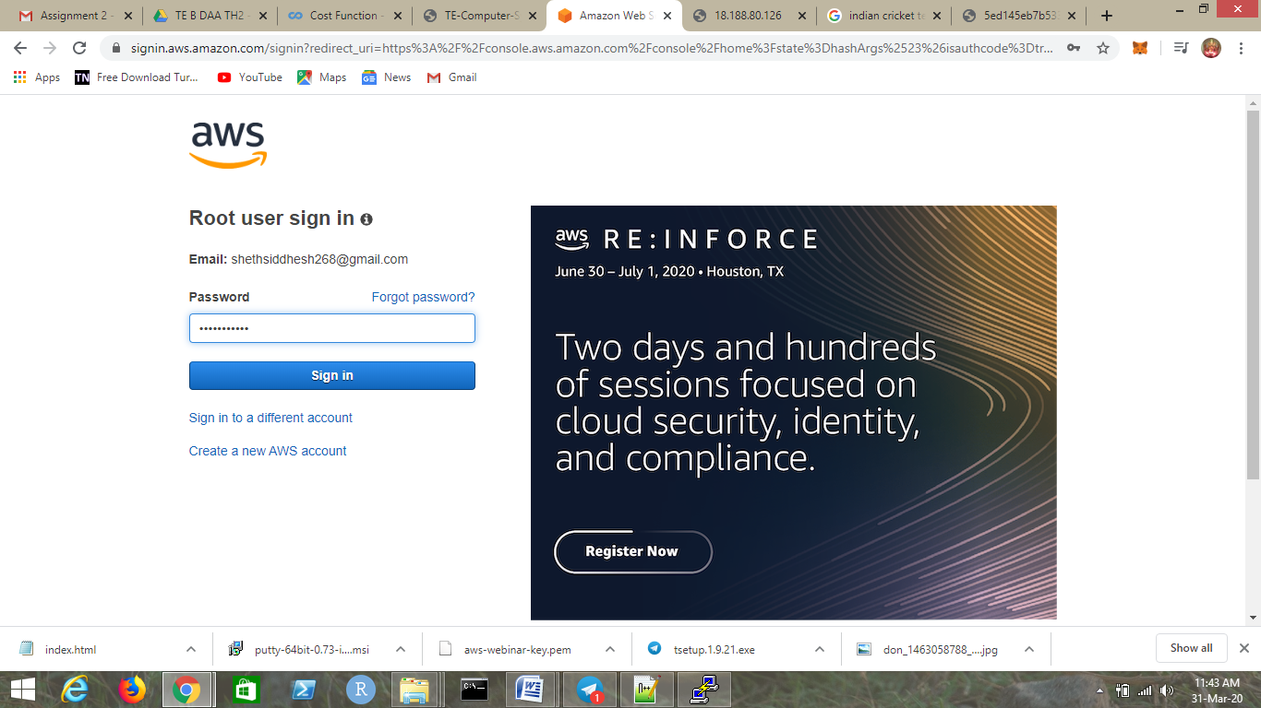

***2.EC2 Dashboard***

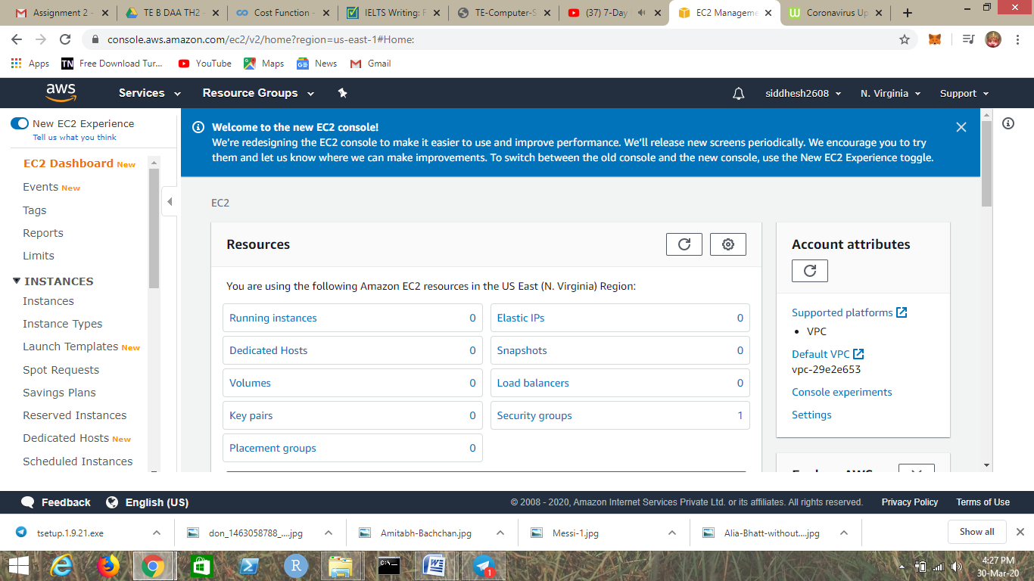

***3.S3 Dashboard***

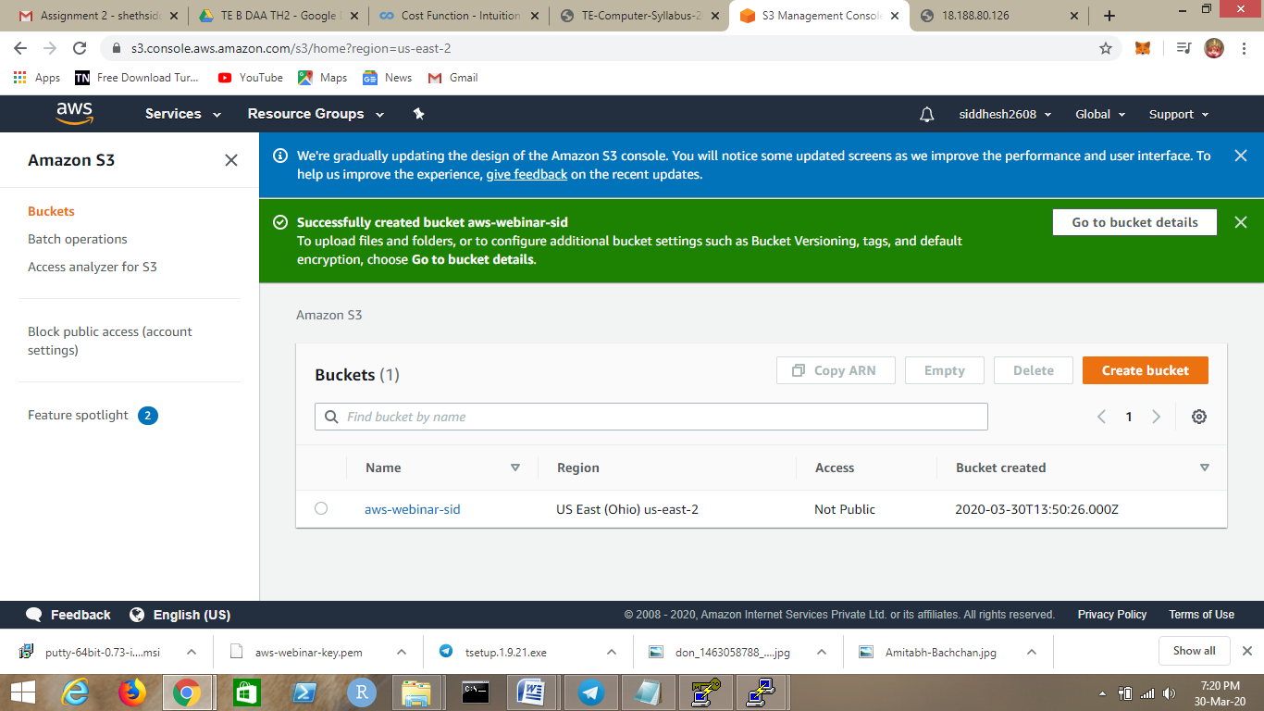

***4. Rekognition Dashboard***

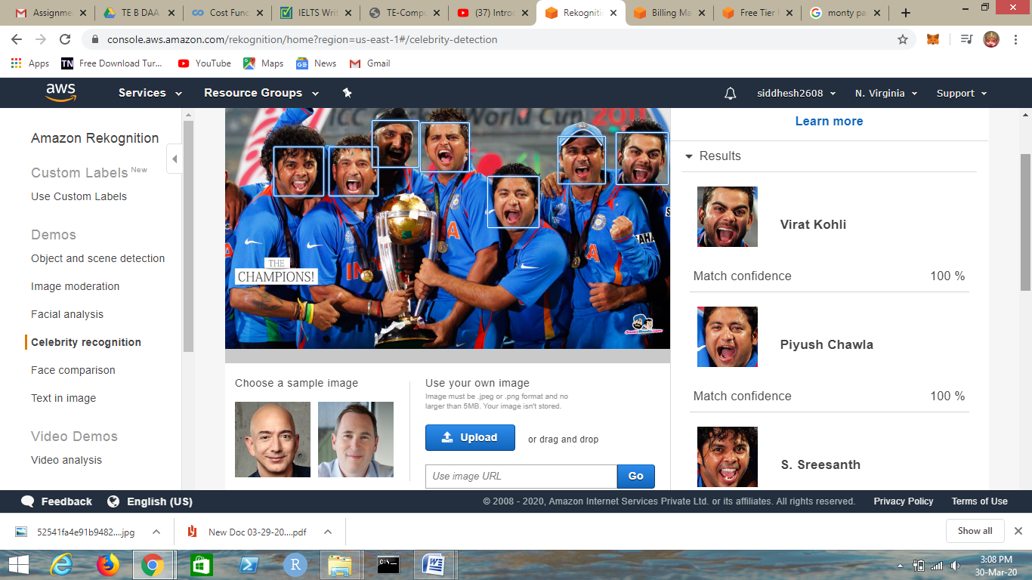

***EC2(Elastic Compute Cloud)***

1. Choosing an AMI

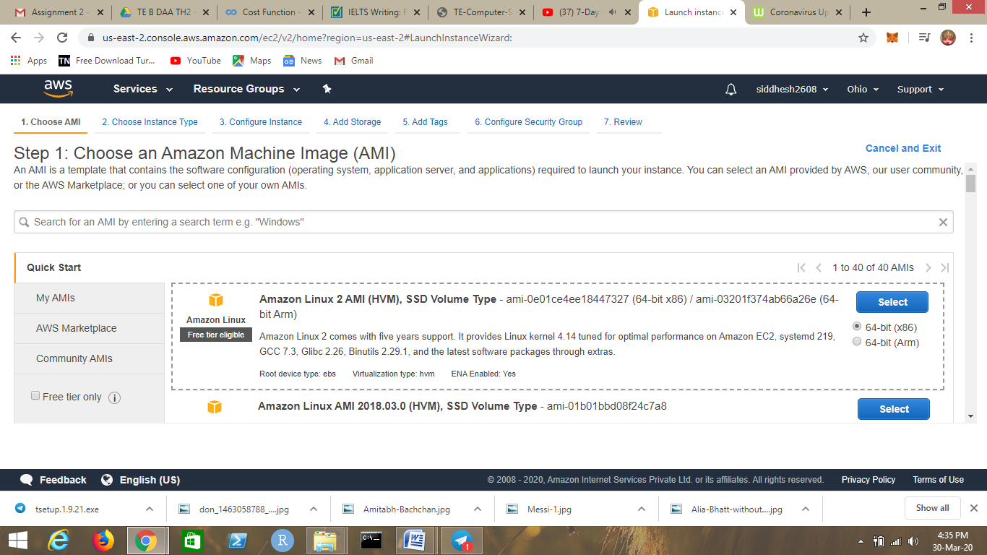

1. Choosing an instance type

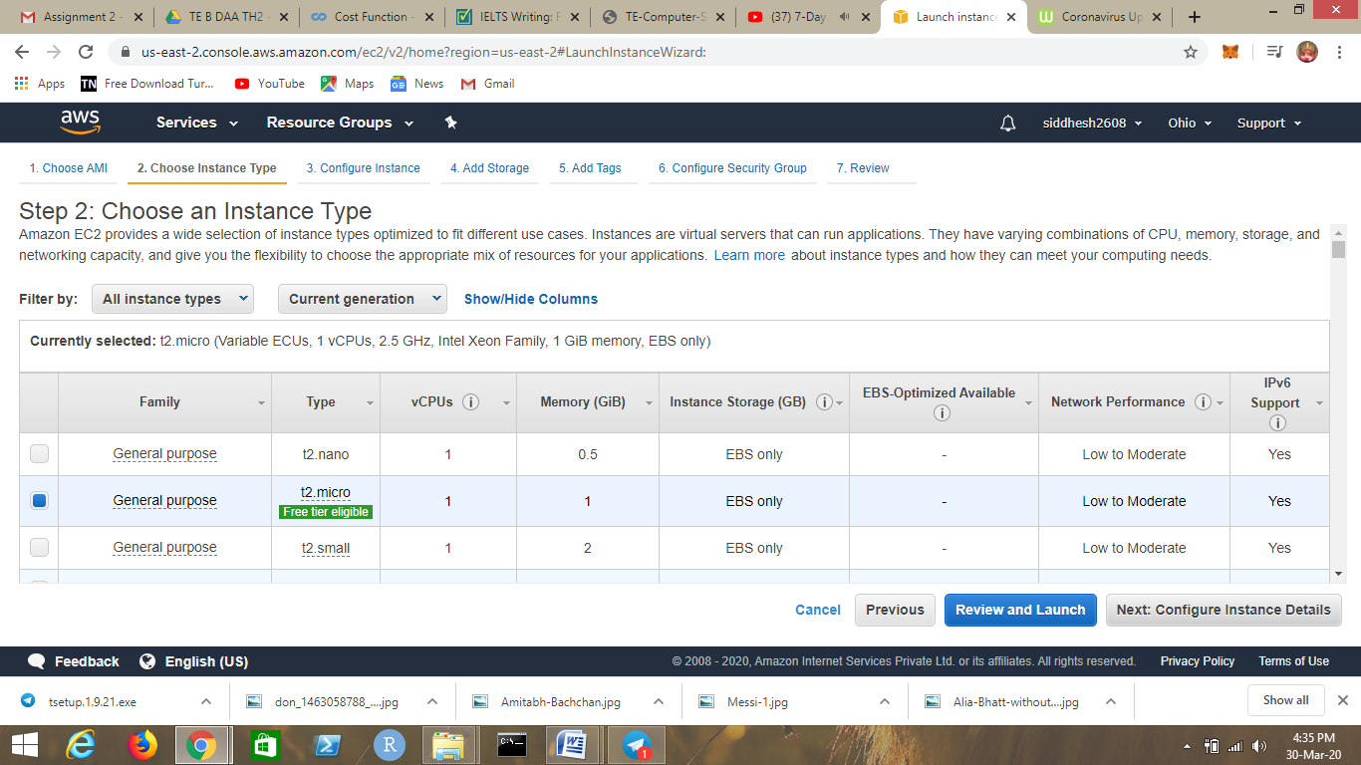

1. Adding Storage

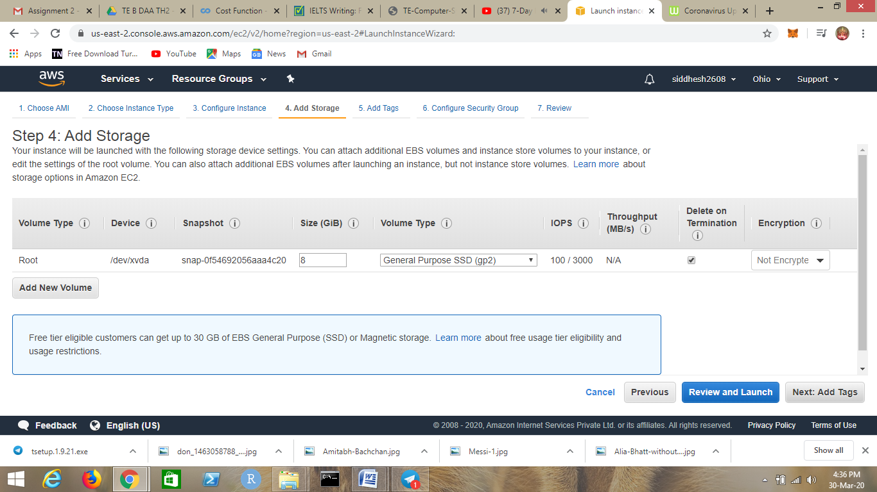

1. Configuring Security Group

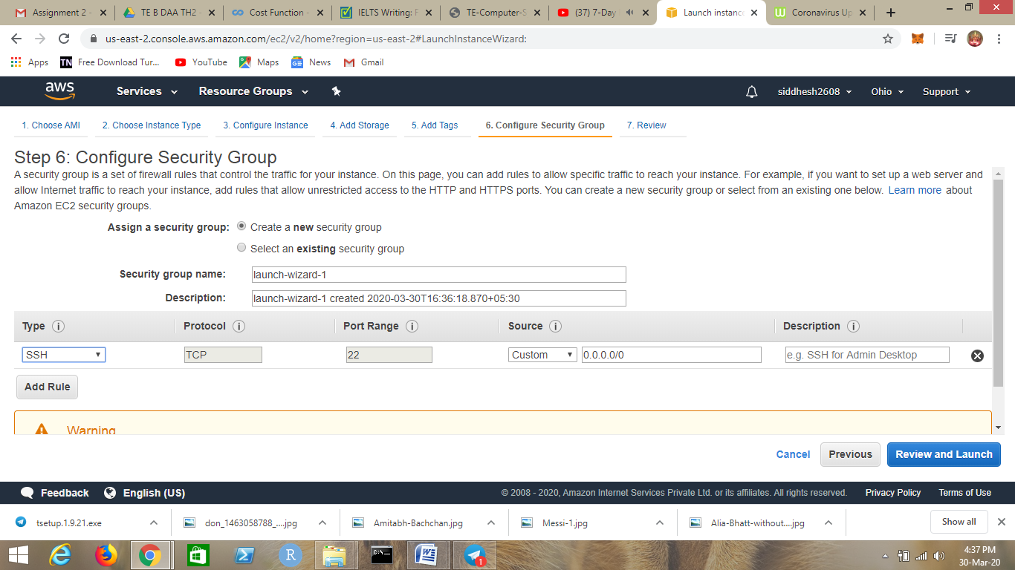

1. Key Pair Download

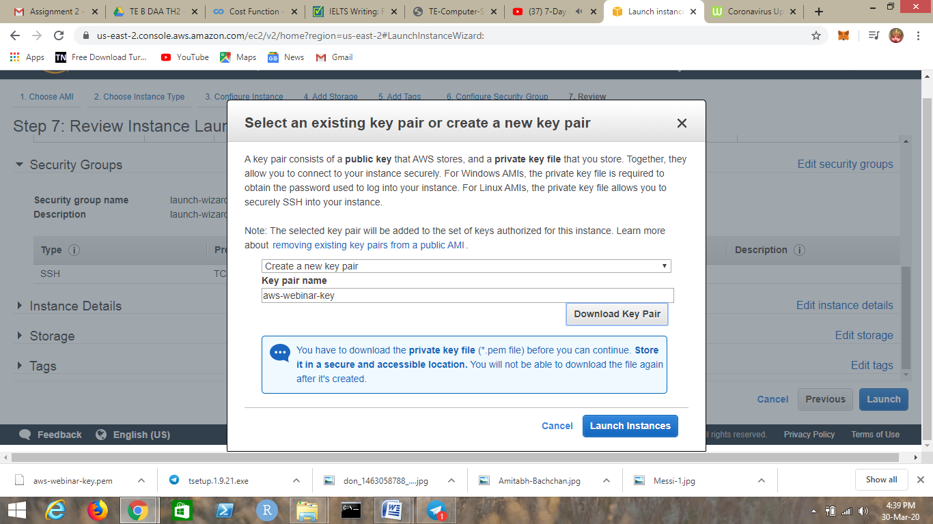

1. PuTTygen conversion from .pem to .ppk

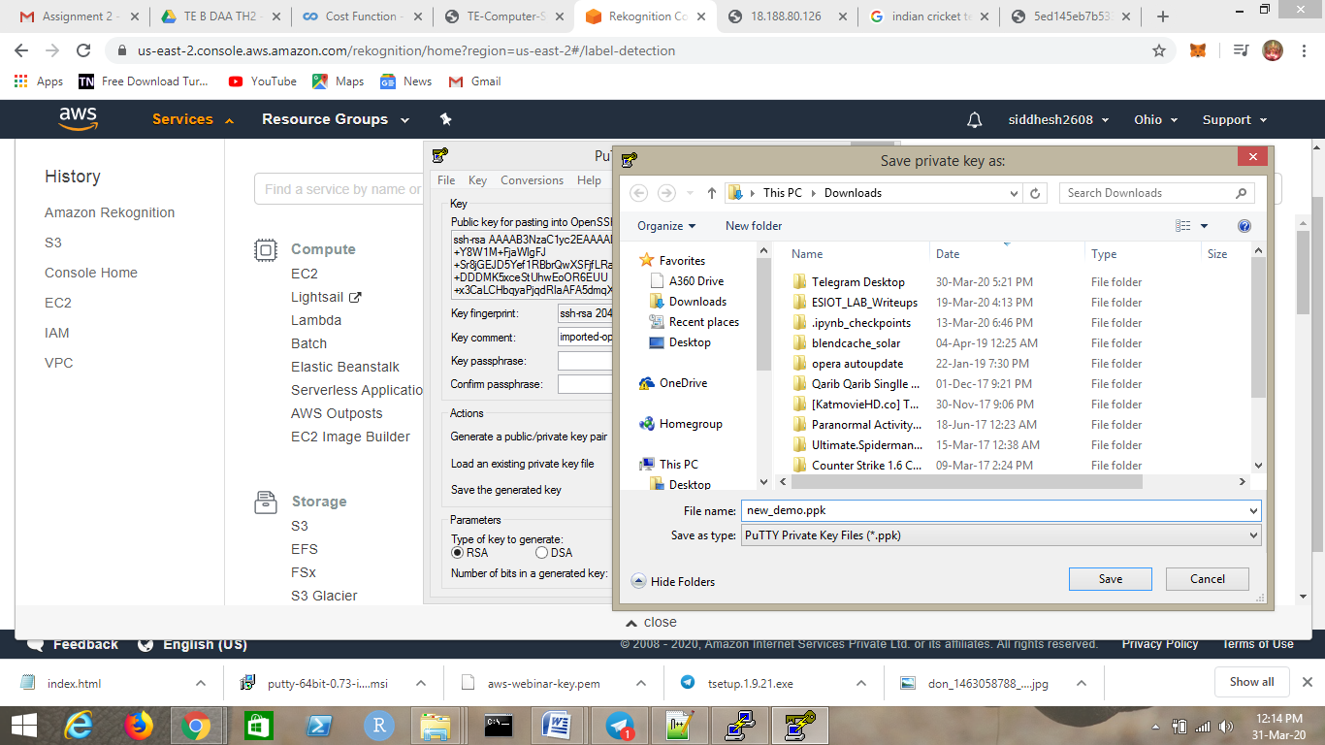

1. Logged in EC2 black screen

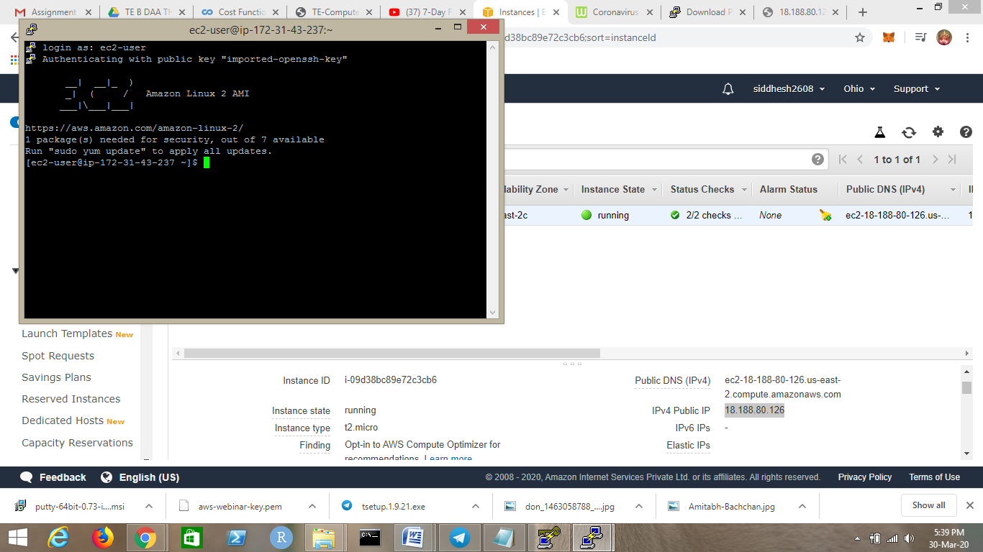

***S3(Simple Storage Service)***

1. Creating a bucket



1. Uploading an object

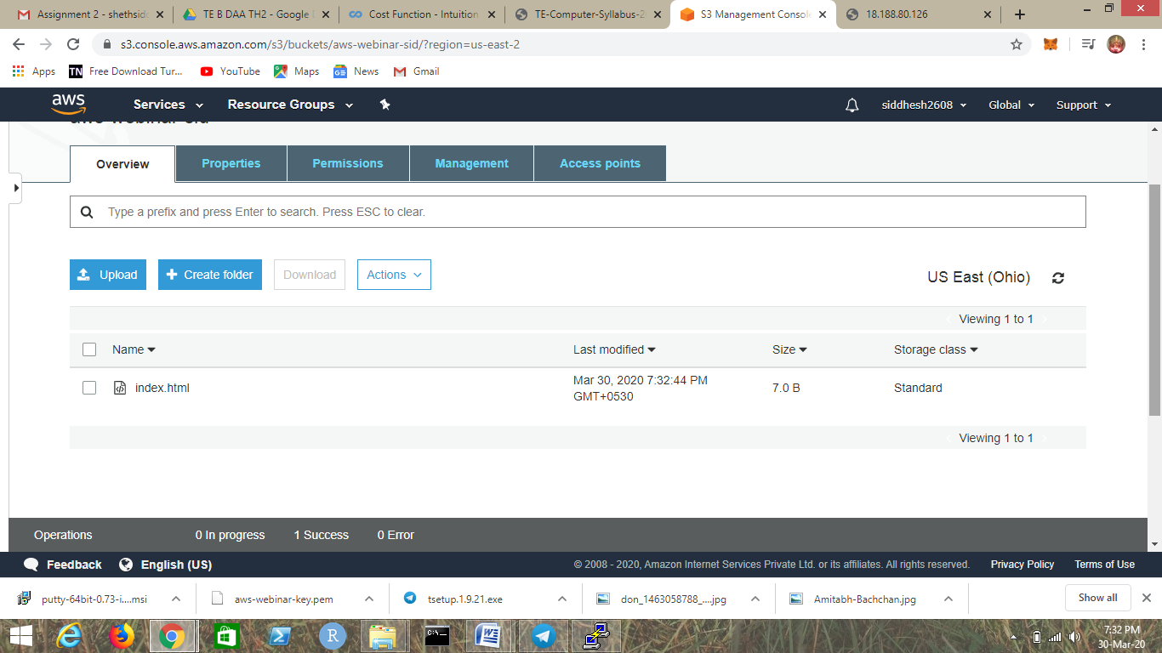

1. Enabling Static Website

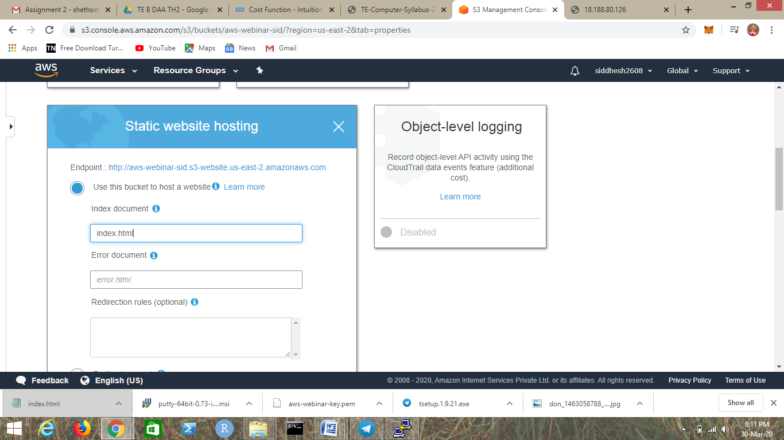

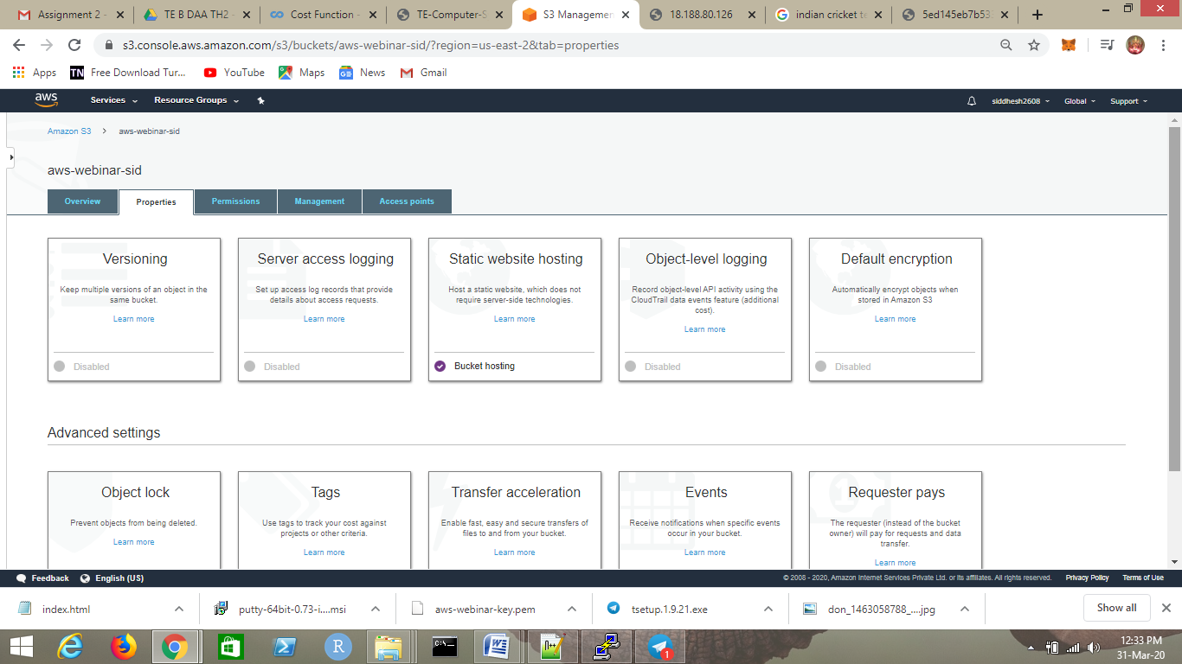

1. Making the object public

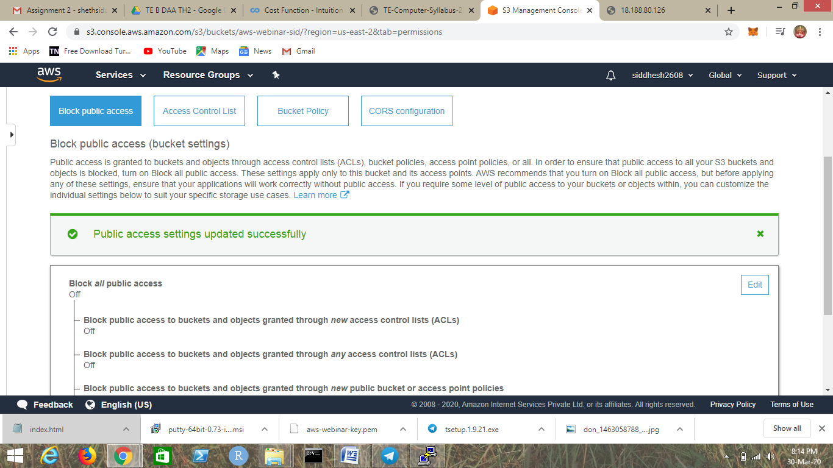

E. Checking the S3 link in the browser

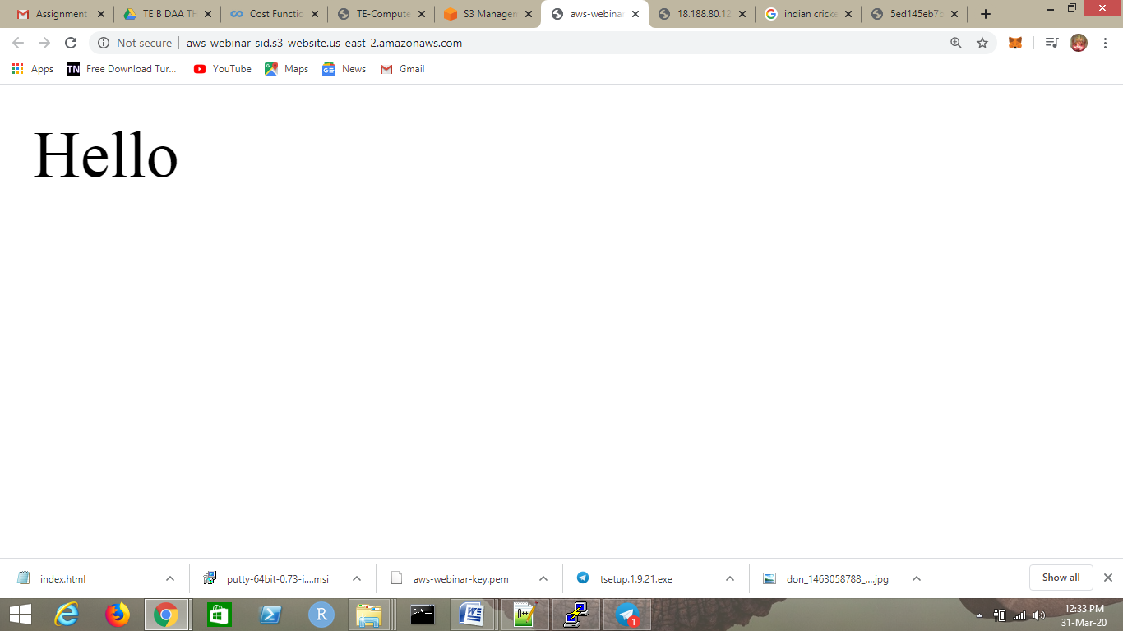

***Rekognition***

1. Object and Scene Detection

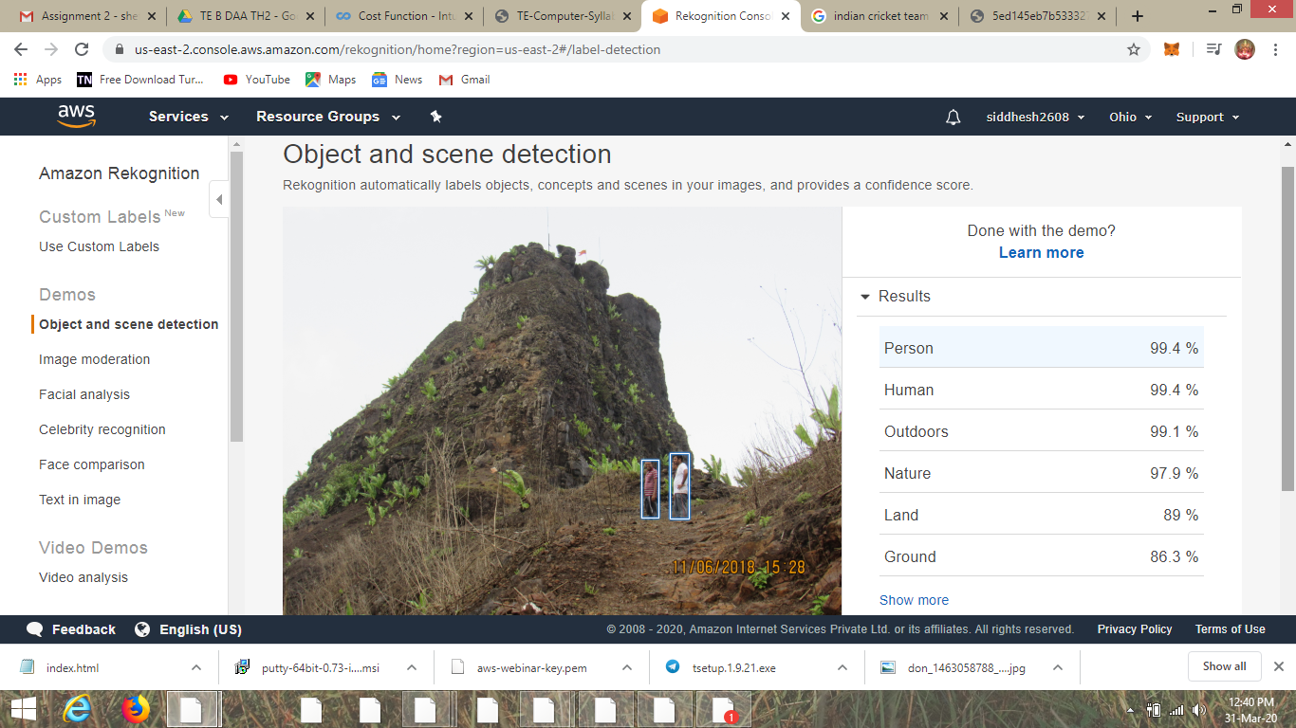

1. Face Compare

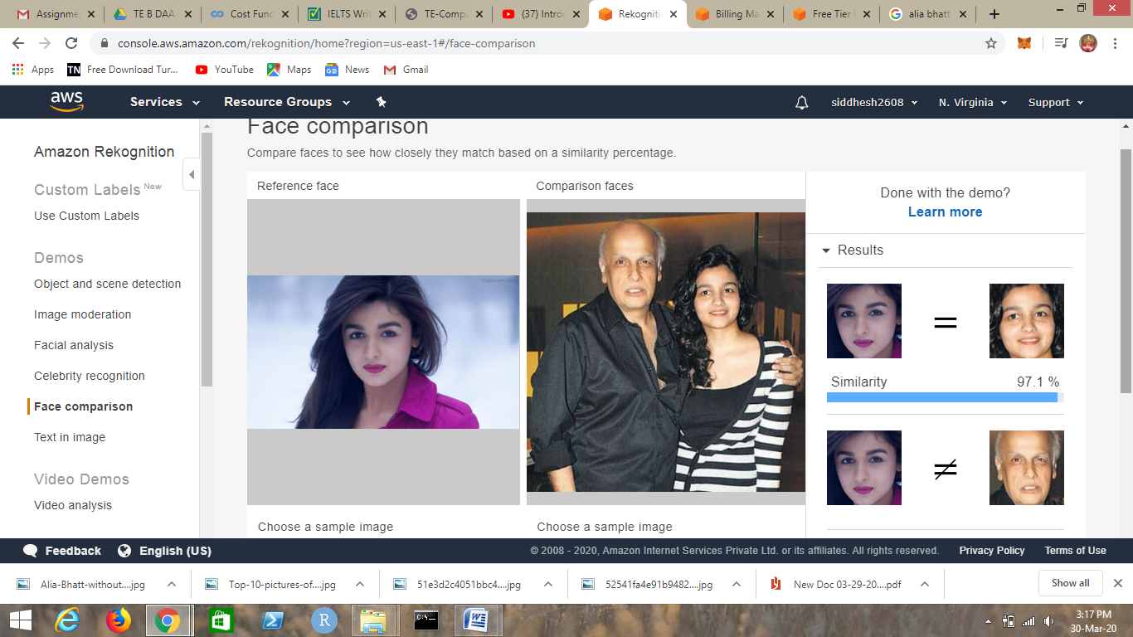

1. Celebrity Recognition



1. Text in Image

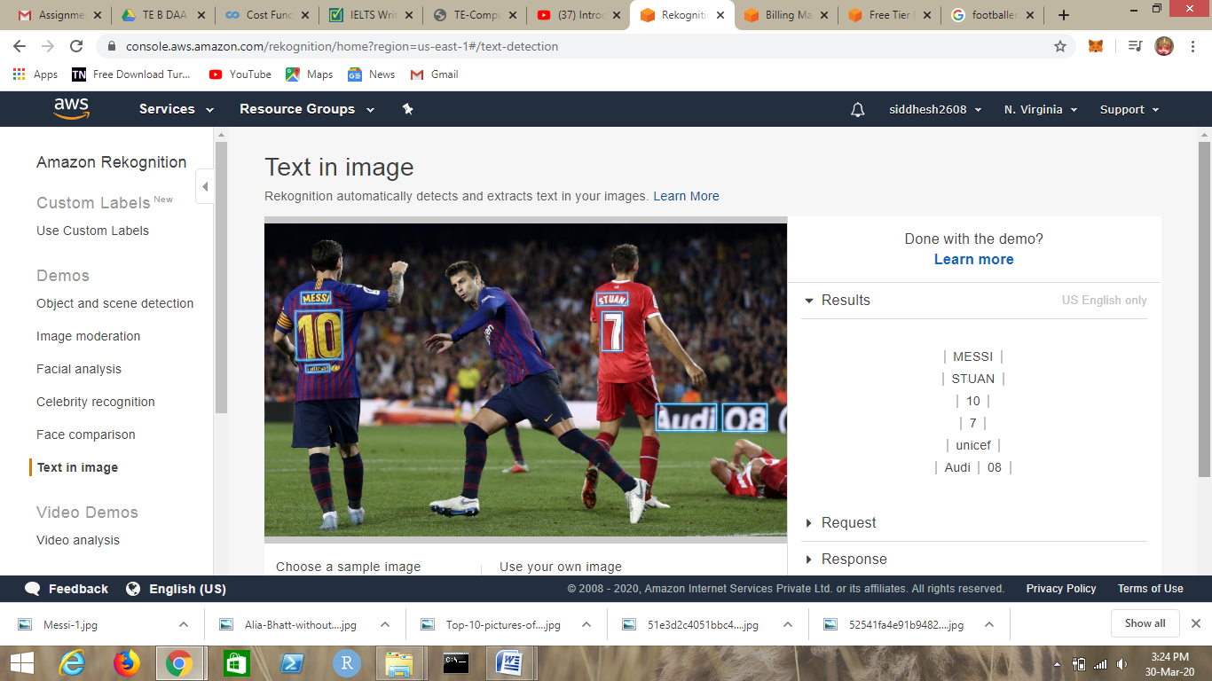

***EC2 & S3***

1. Installing aws-sdk

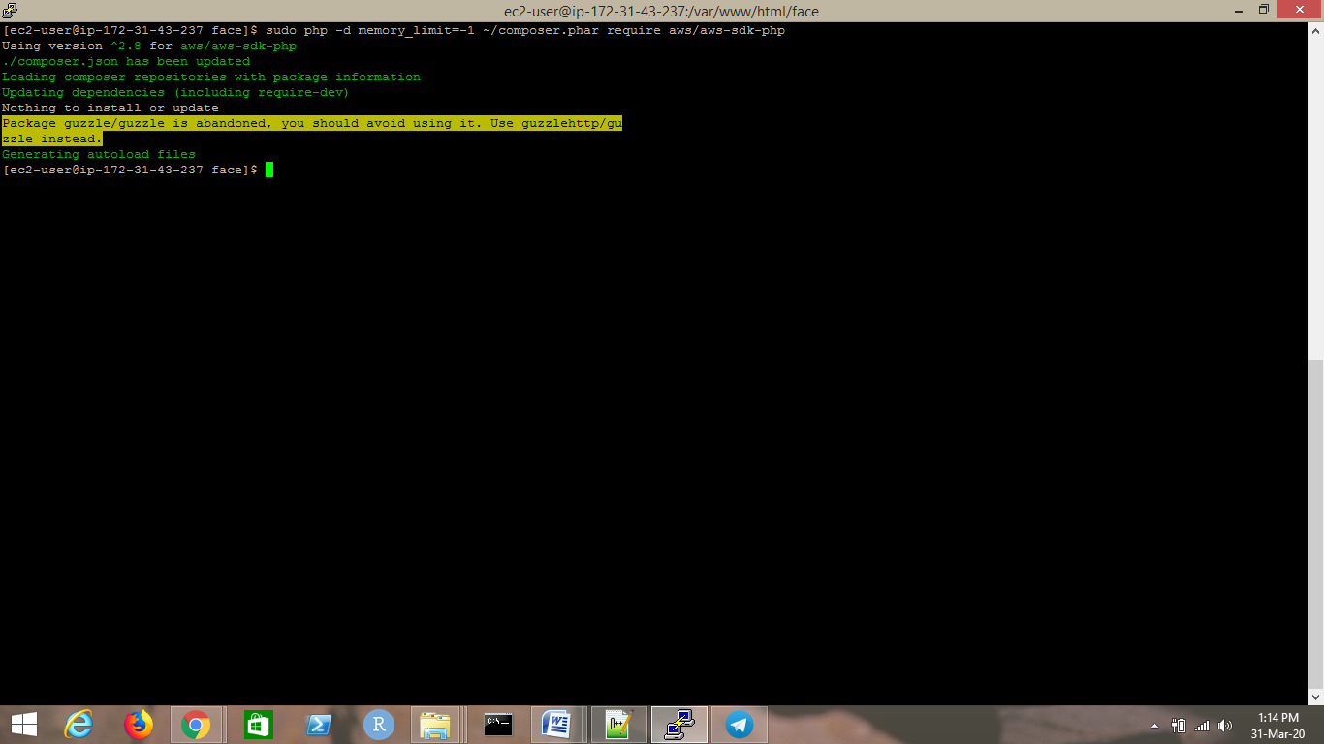

1. Installing php

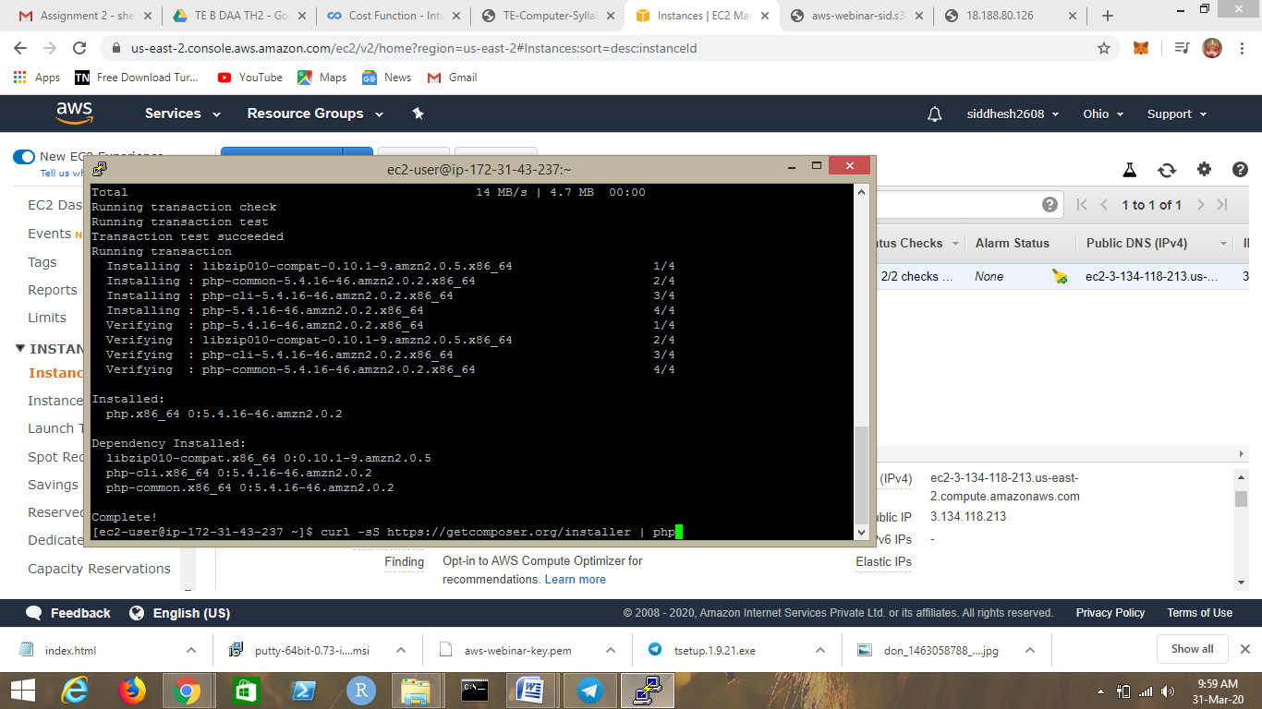

1. index.php file code

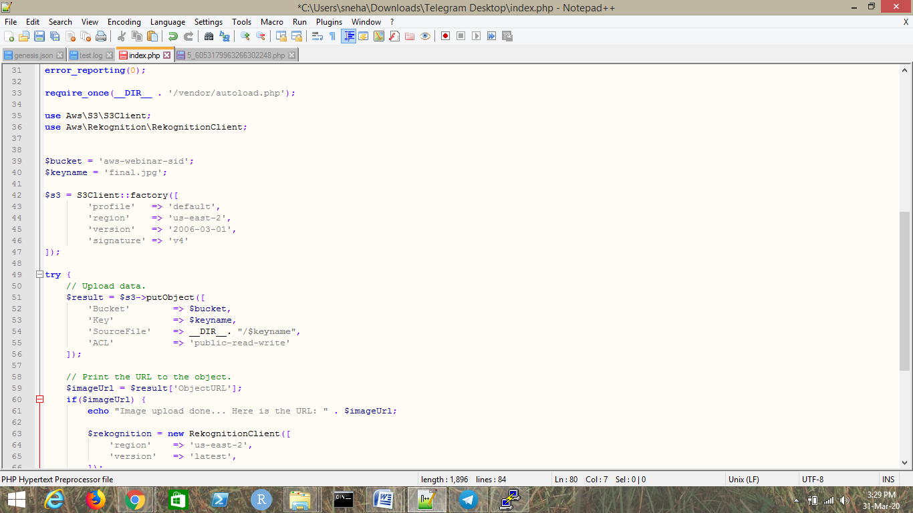

1. Upload Success ScreenShot

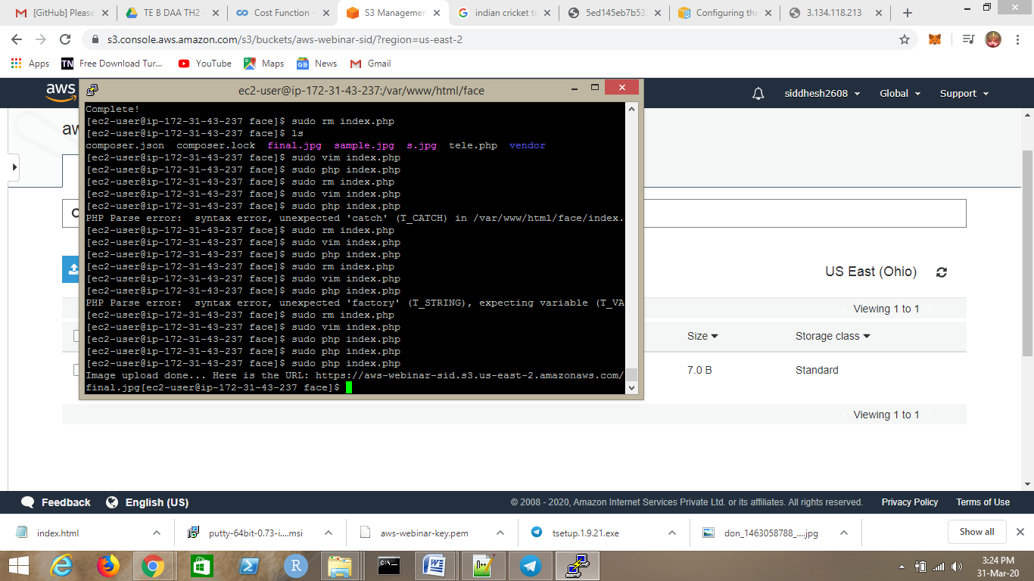

***EC2 and Rekognition***

1. Face detect and success screenshot

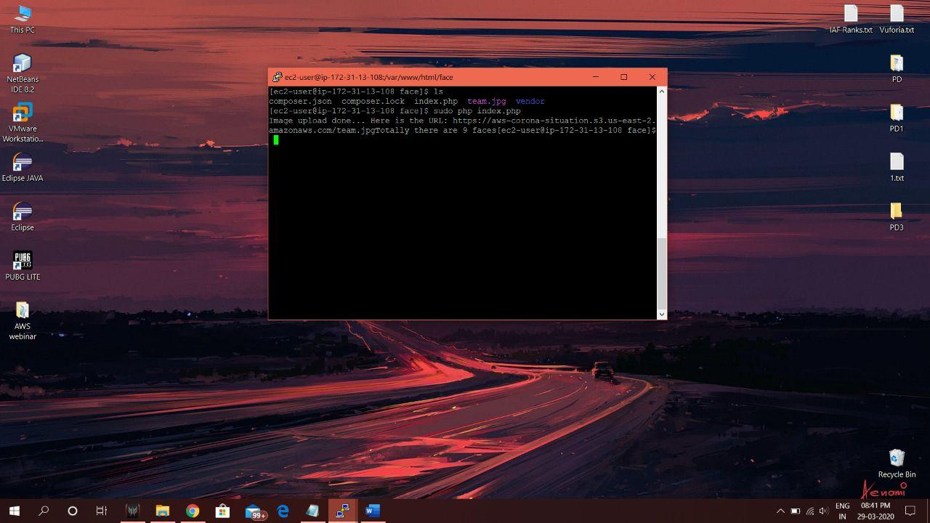

This one I have taken from my friend's machine.